**Code:**

import PySimpleGUI as sg

from PIL import Image, ImageEnhance, ImageFilter, ImageTk, ImageDraw, ImageFont

import matplotlib.pyplot as plt

first_line = [sg.FileBrowse(), sg.Input(key="filepath")]

second_line = [sg.Button("Original Image", key="Original Image", size=(15, 1)),

sg.Button("Contour", key="Contour", size=(15, 1)),

sg.Button("Blur", key="Blur", size=(15, 1))]

third_line = [sg.Save(key="Save"), sg.Cancel()]

image_line = [sg.Image(key="showimage"), sg.Image(key="edit_image")]

layout = [first_line, second_line, third_line, image_line]

Title = "Image Viewer and Editor"

window = sg.Window(Title, layout)

while True:

event, value = window.read()

im_path = value["filepath"]

if event == "Original Image":

im = Image.open(im_path)

window["showimage"].update(data=ImageTk.PhotoImage(im))

if event == "Contour":

im = Image.open(im_path)

new_im = im.filter(ImageFilter.EMBOSS)

new_im = show()

if event == "Blur":

im = Image.open(im_path)

new_im = im.filter(ImageFilter.BLUR)

window["edit_image"].update(data=ImageTk.PhotoImage(new_im))

if event == "Save":

im.save('new_im.jpg')

if event == "Cancel" or event == sg.WIN_CLOSED:

break

window.close()

1. Selecting an image present in the user's system

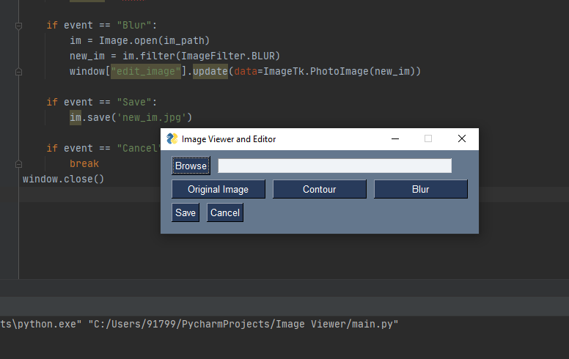

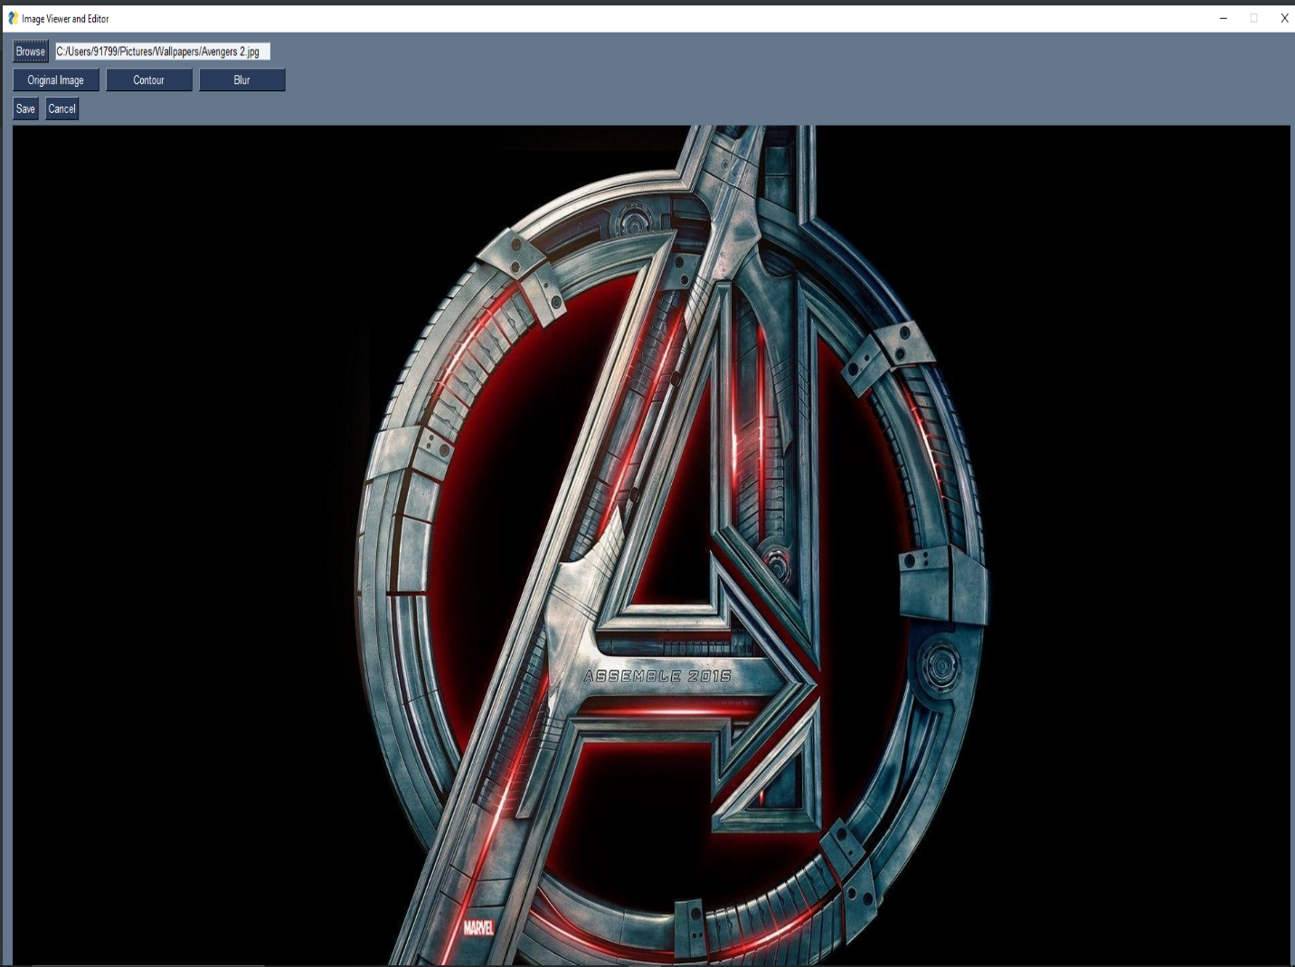

1. View the selected image

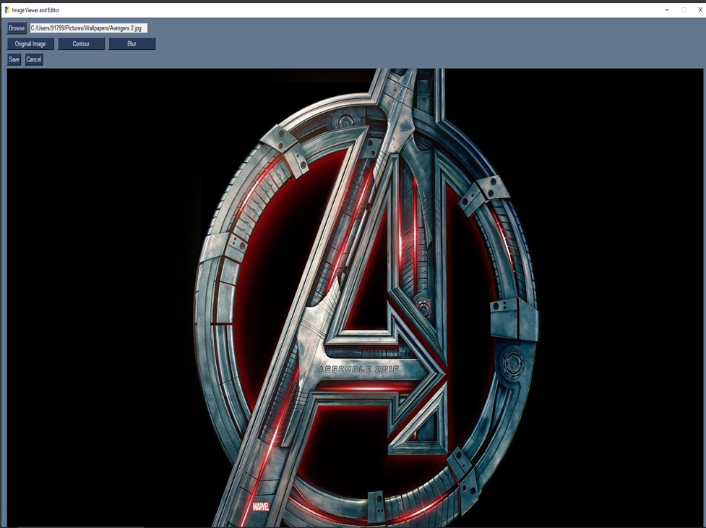

1. Performing image manipulations

